

The Laguna State Polytechnic University

**QUALITY MANUAL**

Table of Contents

## 1.0 General Information 3

* 1. Distribution List 3
  2. Scope of the Quality Manual 3
  3. Objectives of the Quality Manual 3

## 2.0 Institutional Profile 4

* 1. Vision Statement 4
  2. Mission Statement 4
  3. Core Values of the University 4
  4. Quality Policy 4
  5. Context of the Organization 4
  6. Quality Objectives 6

## 3.0 Process System 7

* 1. Business Process Map 7
  2. Organizational Chart 8
  3. Roles and Responsibilities 9

## 4.0 Communication Flow 11

## 5.0 Management Review 11

## 6.0 Risk Management 12

6.1 Risk Register 12

* 1. Updating 12
  2. Printing 12
  3. General Information
  4. Distribution List

This manual shall be made available to all process owners of the University. The authorized version of the manual shall be distributed by the following high level offices to their supervised units:

Office of the University President Office of the Vice-Presidents Office of the Campus Directors Document Control Officer Internal Quality Audit Office Office of the Director for ICTS

The LSPU ICTS/webmaster shall upload the most recent version of this manual. Process owners may access the manual in the lspu.edu.ph website.

* 1. Scope of the Quality Manual

This quality manual outlines the quality management system established by Laguna State Polytechnic University known as “LSPU” as per ISO 9001 requirements and is applicable to all functions in the organization, including:

* + - determination of educational and other requirements of its clients,
    - design and development of curriculum and syllabus,
    - promotion of curricular programs,
    - admission and registration of students,
    - administrative and academic support services, and
    - delivery of instruction, research and extension, production services, student evaluation, assessment and graduation from the different colleges of the University:

College of Agriculture, College of Teacher Education, College of Fisheries, College of Engineering, College of Industrial Technology, College of Hospitality Management and Tourism, College of Arts and Sciences, College of Criminal Justice Education, College of Computer Studies, College of Business Management and Accountancy, College of Food Nutrition and Dietetics, and College of Nursing and Allied Health, at Sta. Cruz Main Campus located at Brgy. Bubukal, Sta. Cruz, Laguna; Siniloan Campus at L. De Leon St., Siniloan, Laguna; San Pablo City Campus at Brgy. Del Remedios, San Pablo City; and Los Baños Campus at Brgy. Malinta, Los Baños, Laguna.

* 1. Objectives of the Quality Manual

This quality manual serves as a guide and reference for University Officials and process owners of the University. It provides a common understanding of the various institutional policies and procedures in the efficient and effective implementation of the quality management system.

* 1. Institutional Profile

|  |  |
| --- | --- |
| Name of institution: | Laguna State Polytechnic University |
| Address of main campus: | Brgy. Bubukal, Sta. Cruz, Laguna, Region IV-A |
| Other campuses: | Siniloan, San Pablo City, and Los Baños |
| Institutional website: | [http://lspu.edu.ph](http://lspu.edu.ph/) |
| Year the university was established: | 2007 |
| Enabling law and charter: | RA 9402 of 2007 |

* 1. Vision Statement

Proposed draft:

The LSPU is a center of productive and sustainable educational services that promote positive societal impacts and better quality of life.

*\*Refer to the LSPU Strategic Plan*

* 1. Mission Statement

Proposed draft:

The LSPU is a steward of resources through its appropriate, efficient, and effective management and utilization, allowing for impactful and sustainable services in terms of instruction, research, extension, and production that enable communities to attain self- sufficiency

*\*Refer to the LSPU Strategic Plan*

* 1. Core Values of the University

Integrity, Professionalism, and Innovation

* 1. Quality Policy

LSPU delivers quality education through responsive instruction, distinctive research, sustainable extension, and production services. Thus, we are committed with continual improvement to meet applicable requirements to provide quality, efficient and effective services to the university stakeholders’ highest level of satisfaction through an excellent management system imbued with utmost integrity, professionalism and innovation.

* 1. Context of the Organization

The LSPU leadership, with top officials, deans and directors, express the context of the university using the SWOT analysis from the Strategic Planning Workshops conducted to correspond with the current National Development Plan. The output of the workshop is the LSPU Strategic Development Plan, which is assessed annually. The current context is summarized as follows:

Relevant Interested Parties and Stakeholders:

|  |  |
| --- | --- |
| CHED | Students and alumni |
| Civil Service Commission | Parents |
| DBM | Community |
| COA | Employing industries |
| AACCUP | Industries in and around Laguna |
| Suppliers | Faculty and employees |
| External Providers |  |
| Local governments of Laguna |  |

SWOT analysis

|  |  |
| --- | --- |
| Strengths | Weaknesses |
| Relevant and accredited programs; Good community relations; Affordability;  Accessible campus locations; Competence;  Autonomy; Strategic location | Inadequate alumni support; Undocumented successful alumni; Low PRC passing rate;  Limited number of published and cited research;  Limited number of commercialized research outputs;  Limited documentation of impacts of extension programs;  Need for additional qualified faculty;  Limited integrated operations or management systems;  Limited state-of-the-art facilities/equipment; Insufficiency of funds |
| Opportunities | Threats |
| Rich cultural heritage with the presence of public-private partnerships and support mechanisms in the heart of the country’s premier growth region;  Industrialization, technology development and economic zones.  Quality assurance certification Accreditation  Growth of research output and commercialization | Natural and manmade disasters; Political intervention;  Budget cuts;  High costs of utilities and equipment; Employee migration;  Education-industry mismatch; and Competition from other HEIs. |

* 1. Quality Objectives = Strategic Objectives

Every 5 years or as needed, a Strategic Development Plan is drafted with Strategic Objectives and targets to meet. The University monitors performance every year during the Annual Assessment of the LSPU Strategic Development Plan.

The following procedure is followed:

* + 1. Strategic Objectives are set at the drafting of the Strategic Development Plan. All aspects of the plan may be reviewed and revised annually by the Vice-Presidents, and Planning Officers. Any revision is approved by the University President.
    2. The Vice-Presidents communicate their respective strategic objectives (SO’s) to directors of

offices/units under them.

* + 1. Directors and their chairpersons establish Office Performance Commitments and indicators that would contribute to the Strategic Objectives of the University as communicated.

2.6.3a OPCR’s are made and reported semi-annually. i.e. they are monitored January to June, and July to December.

* + 1. b Indicators for strategic objectives are reported annually at the strategic plan assessment but are monitored quarterly.
    2. The Office Performance Commitment Review (OPCR) identifies targets, measures, activities, resources needed, and persons responsible for the accomplishment of targets.
    3. Other pertinent details on the Strategic Objective processes may be referred to the Planning Office.

Document Control of OPCR’s

* + 1. OPCR’s are reviewed by the immediate supervisor, Campus Director or VP, and approved by

the University President.

* + 1. The approved copy is collected and stored by the Planning Office per campus.
    2. The Planning Office shall provide copies of approved OPCR’s to the Colleges and Units. Performance Monitoring
    3. OPCR’s with accomplishment data shall be given to the appropriate immediate supervisor.
    4. The immediate supervisor of the offices and colleges shall evaluate and rate the performance based on the performance management system guidelines provided by regulating agencies (DBM or CSC).
    5. Original copies of the rated OPCR’s shall be kept by the Planning Office or MIS.
    6. Copies are to be provided to the unit/college.
  1. Process System
  2. Business Process Map

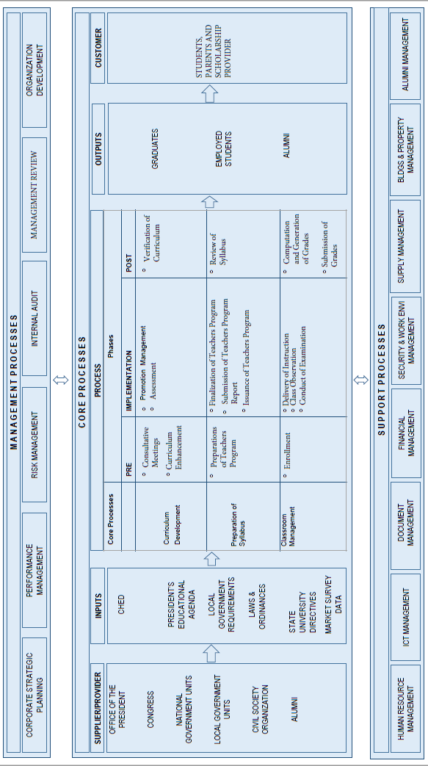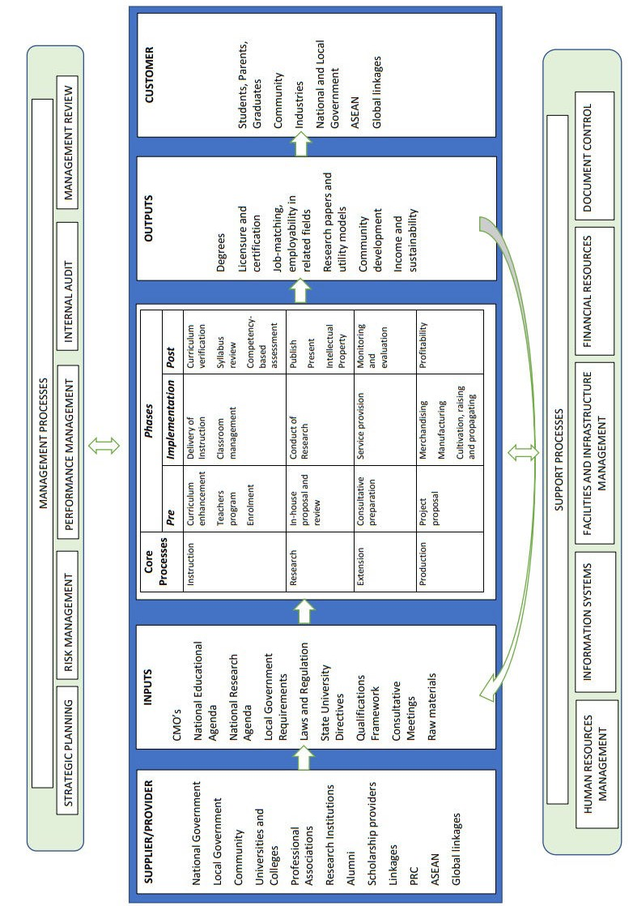

*Page* ***7*** *of* ***12***

Republic of the Philippines

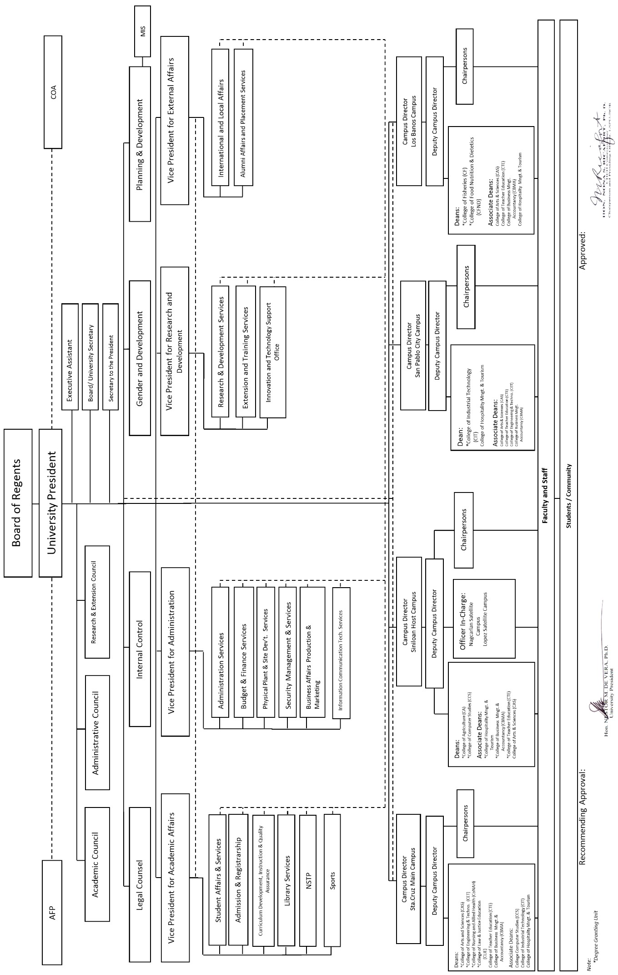

# Laguna State Polytechnic University

## QUALITY MANUAL

* 1. Organizational Chart
  2. Roles and Responsibilities

President

* + - Performs the duties and functions of the position as mandated under Republic Act 9402;
    - Administers the affairs of the University;
    - Performs other functions as may be assigned by the Board of Regents.
* May designate a Management Representative for university risk management.
* Ensures that a quality management system is established, implemented and maintained in accordance with ISO 9001 standard requirements;
* Promotes awareness of customer requirements and applicable requirements throughout the organization; and
* May delegate functions to University Officials.

Vice President for Academic Affairs

* + - Assist the University President in the implementation of educational policies and programs and other academic activities of the University;
    - Monitor and evaluate current curricula, courses, materials, methods of instruction,

admission requirements, and other academic matters’ recommendation;

* + - Coordinates with other departments/offices of the University to ensure inter-program complementation and efficient maximization of available resources;
    - Performs other related duties that maybe assigned from time to time by the University President.

Vice President for Administration

* + - Oversees the operation of the administrative and finance services and performs coordinative and supervisory task in the implementation of policies pertaining to administration;
    - Assists the University President on matters pertaining to policy formulation and acts as Officer in Charge in the absence of the President;
    - Performs other related duties that maybe assigned from time to time by the University President.

Vice President for Research, Development and Extension

* + - Oversees, consolidates and recommends to the University President the research, extension and production thrusts, program and budget;
    - Monitors and evaluates on-going and completed researches, extension and production programs/projects conducted by the University;
    - Performs other related duties that maybe assigned from time to time by the University President.

Campus Directors

* + - Ensures that the QMS is established, implemented and improved in their respective campuses;
* Assists the President in the performance of duties;
  + - Conducts management reviews and risk management in the campus;
    - Performs such other duties and functions assigned by the President.

Lead Auditor

* + - Prepares a yearly schedule of internal quality audit;
    - Discusses the necessary preparations, formulations of the audit plan, other audit activities, and timetable;
    - Ensures objectivity and impartiality of audit to avoid conflict of interest and bias in opinion;
* Presides over the opening meeting prior to the conduct of audit;
* Presides over a closing meeting as soon as the audit has been finished by discussing results of the audit;
  + - Elevates to the department head unresolved issues with the auditee;
    - Prepares the internal quality audit result and submits to the CD or President for review and approval;
    - Provides all auditees with copy of findings of non-conformance report but distribution of audit report is subject to the discretion of the CD or President;
    - Elevates to the CD or President corrective actions not implemented on the committed date;
    - Maintains and files internal quality audit records in accordance to control of documents and records procedures; and,
    - Ensures that the documented internal quality audit procedure is implemented.
* May delegate any of the functions and/or authorities to IQA Team Leaders of LSPU campuses

IQA Team Leaders

* Manages the team of internal auditors and the conduct of internal audit within their respective campus;
* Submits audit reports to the Management Representatives, Campus Directors and the Lead Auditor.

Internal Auditor/s

* + - Prepares the necessary audit checklists to ensure that all the important items/elements are covered;
    - Conducts the audit by interviewing the auditee and the area being audited or desk audit (review of applicable documents, and/or checking of actual implementation against documented procedures;
    - Notes down on the checklist all the necessary findings during the time of audit, including the objective evidence of conformances and/or non-conformances;
    - Evaluates their findings and deliberates on the non-conformance found during the audit;
    - Conducts follow-up audit at least two (2) days after implementation of the corrective action even without prior announcements to verify if the committed action is implemented;
    - Conducts another follow up audit preferably a minimum of one (1) month after another follow up audit shall be done to verify the effectiveness of the implemented action, to be recorded in the monitoring log.

Document Controller

* + - Ensures the necessary control of the approval, issuance, review, update and re-approval of documented information; identification of the changes made and current revision status; availability of the documents at point of use; and control of external and obsolete documents;
    - Ensures the necessary control for the identification, storage, protection, retrieval, legibility, retention time and disposition of documented information;
    - Responsible for the implementation, monitoring and control of documents and records as per procedures described in LSPU-PM-01 (Control of Documents and Records).

4.0 Communication Flow

LSPU has established appropriate communication processes such as but not limited to regular meetings with different departments/levels in the organization, awareness, trainings, memoranda, school organs, e-mails, inter-office memos, circulars, resolutions, information boards, etc. to share information to ensure the effectiveness of the quality management system.

Written and documented communication from internal and external sources shall be controlled, especially those involving the Office of the President down to the process units. The manner of control is detailed by the following communication flow:

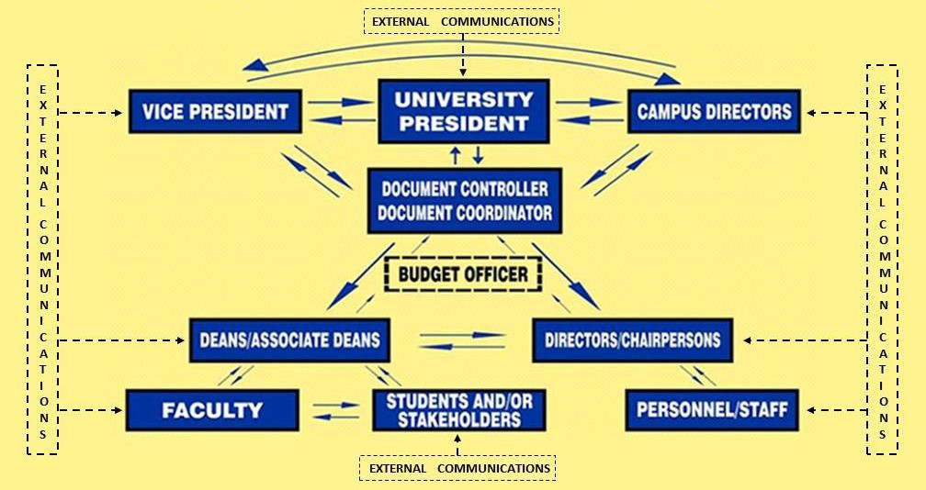

However, for request letters needing funding, funds availability must first be certified by the Budget Officer before the letter can be processed by the DCO. If a purchase request can not be funded, Budget Officers shall note it down on the purchase request, and return it to the requesting unit. These returned letters shall be retained by the requesting unit according to rules of retention.

5.0 Management Review

The campuses may conduct their management reviews covering the QMS within their respective campuses. The Campus Director shall call for an Administrative Council meeting, representing campus management. In the campuses, management reviews may be conducted after internal audit, or as the need arises, to discuss and assess problems and effectiveness in the fulfillment of requirements and indicators of the quality management system and opportunities for improvement.

At the university-wide level, both the annual Strategic Planning and Assessment, and the Administrative Council meetings, discuss management review inputs and strategic objective monitoring. Management review inputs, discussion and resolution of issues from these meetings shall be retained.

* 1. Risk and Opportunity Management
  2. Risk Register and Opportunity Register

The University shall maintain a University Risk Register and Opportunity Register which shall identify prioritized risks of processes within the Quality Management System. These are for high level issues needing the appropriate level of response, such as university-wide activity and policy formulation. The VPA is the assigned University Risk Manager.

The University shall also maintain a register of identified risks and opportunities identified by the academic affairs and the office directors. The functional directors and deans of colleges shall coordinate the risks and opportunities within their respective processes, departments and/or offices; and shall involve chairpersons and associate deans in the management of their respective risks and opportunities.

These registers are stored electronically and its iterations are to be printed before management reviews. The MIS Director controls the copy of the register.

* 1. Updating

Process owners may identify and analyze the risks involved in their processes and environment. Action plans to treat or mitigate the identified risks are the responsibility of the risk owners. Any changes in the analysis of risks due to treatment or situational changes are to be coursed through the dean/director and are then reported to the MIS Director for updating within the register. Any newly identified risks should likewise be reported.

* 1. Printing

Current iterations of the Risk Register may be printed before audits to present as documented evidence. The University Risk Register and its access is to be controlled by the assigned LSPU Risk Manager.

Reviewed by:

**CORAZON N. SAN AGUSTIN, Ph.D. EDEN C. CALLO, Ed.D.**

VPRE VPAA

Date: Date:

**Engr. BELTRAN P. PEDRIGAL**

VPA

Date:

Approved by:

**MARIO R. BRIONES, Ed.D.**

University President Date:

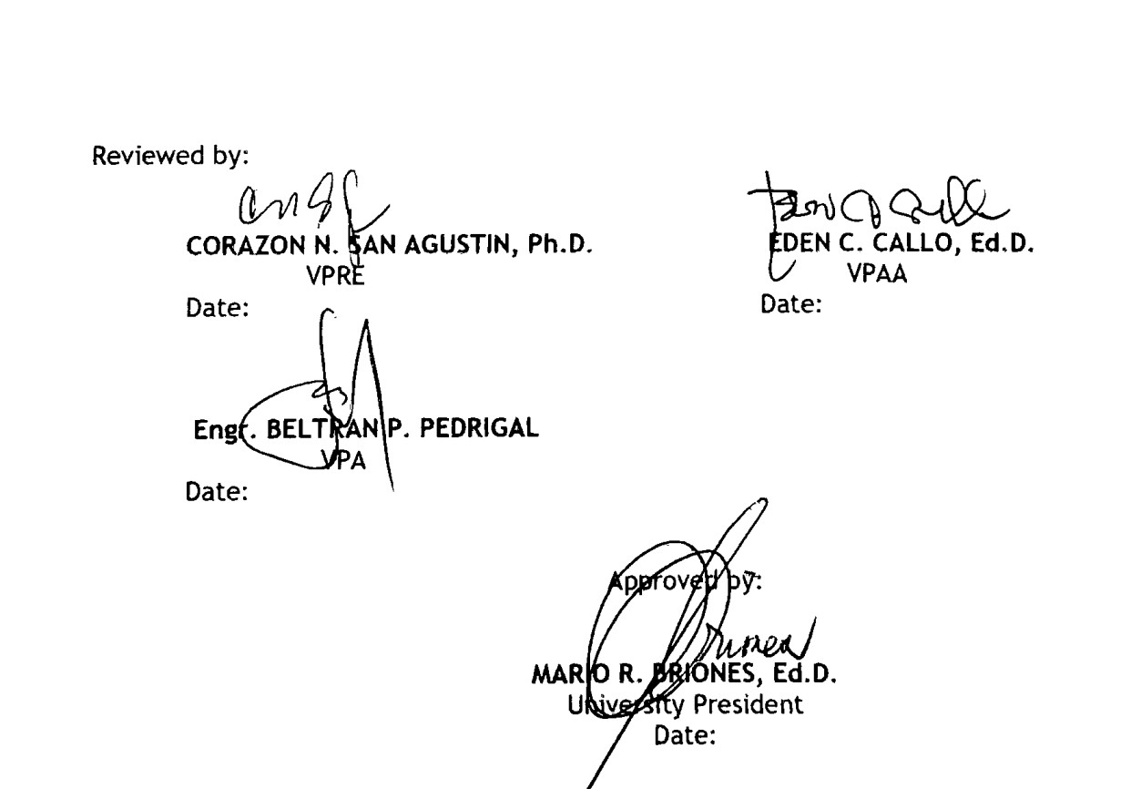

Sept. 25, 2019 Sept. 25, 2019

Sept. 25, 2019

Oct. 2, 2019